

Online Shopping System

Dec 2023

Version 1.0

**Group 46**

members:

CASTRO FREIBOTT Rodrigo 23011608x

CHANDRA Kent Max 22107416d

CHAR Cheuk Tung George 22055747d

WEI Kasey 23011583x

ZHEN Zihao 22100776d

WANG Youkang 22097007d

Table of Content

1. Introduction 5

1.1. Overview 5

1.2. General Functionalities 5

1.3. Notice for Users 7

2. How to setup our OSS 7

2.1. Download the current version of the HTML/PHP files 8

2.2. Open cmd 8

2.3. Connect to the Linux server in your cmd 9

2.4. Create the public_html folder and make it executable for the other 10

2.5. Upload the HTML/PHP files to the Linux server 10

2.6. Check files 11

2.7. Make HTML and PHP files readable to others 11

2.8. Run 12

3. Customer's views 12

3.1. Main menu 12

3.2. Log in 13

3.3. Sign up 14

3.4. Customer home page 15

3.5. Sign-out 16

3.6. Edit Personal Information 16

3.7. Edit addresses 17

3.8. Search product (not finished) 18

3.9. Product detail 20

3.10. Shopping Cart 20

3.11. Checkout 21

3.12. Review system 22

4. Administrator's views 24

4.1. Main menu 24

4.2. Login 24

4.3. Sign up 25

4.4. Administrator home page 26

4.5. Sign-out 26

4.6. Edit personal information 27

4.7. Edit store information 28

4.8. Find product list in administrator store 29

4.9. Edit Product Information 29

4.10. Edit product price and quantity 31

4.11. Add product to the store 32

4.12. Report generation 33

5. Appendix 34

5.1. Contact Information 34

# Introduction

## Overview

With the development of technology, online shopping has become an integral part of people’s daily lives. To provide a seamless and convenient online shopping experience, we have developed a user-friendly Online Shopping System (OSS).

Our OSS is a database-driven application that utilizes SQL statements to implement the online shopping system. It also provides the Graphical User Interface (as a website) to give the best experience for the user.

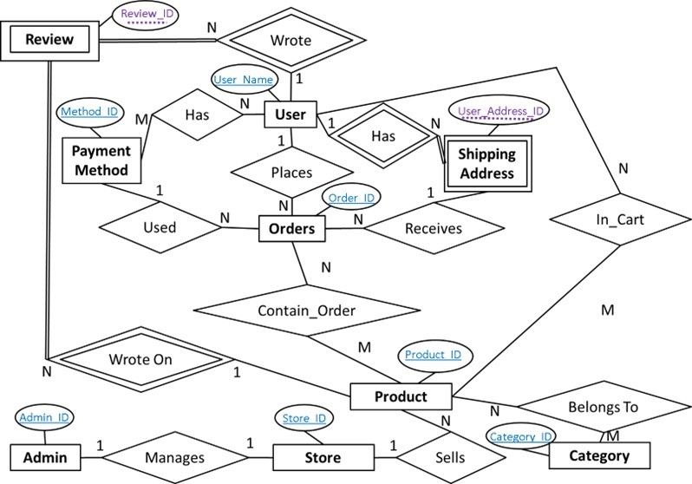  
Here is the ER (Entity Relationship) diagram for our OSS. You can see the relationship between each entity.

## General Functionalities

The following is a general introduction to all the essential functionalities our system supports as an Online Shopping System.

For normal users, firstly, it provides user account management, allowing users to create accounts and authenticate themselves securely. Users can also update their personal information, manage shipping addresses, change passwords, and more. Secondly, OSS showcases a wide range of products and provides detailed information about each product, including descriptions, specifications, prices, and customer reviews. Users can search and filter products based on different criteria such as category, price range, brand, etc. Additionally, OSS supports features such as a shopping cart and checkout, where users can add items to their cart, select quantities (subject to availability), choose delivery addresses, and proceed with payment.

For administrators, OSS offers advanced functionalities such as inventory management and report analysis. The inventory management feature allows administrators to manage product stock, including adding/deleting/updating products, updating stock levels, and assigning categories to products. The report analysis feature generates analytical reports for administrators to view system status, such as sales data, popular products, and user behavior. Those can help us to enable further measures such as promotions/discounts.

* **User Account Management:** Allowing users to securely create accounts and authenticate themselves. Users can also update their personal information, manage shipping addresses, change passwords, and more.
* **Product Listings and Search: S**howcases a wide range of products and provides detailed information about each product, including descriptions, specifications, prices, and customer reviews. Users can search and filter products based on different criteria such as category, price range, and brand.
* **Shopping Cart and Checkout:** OSS supports features such as shopping cart and checkout, where users can add items to their cart, select quantities (subject to availability), choose delivery addresses, and proceed with payment.
* **Inventory Management:** OSS offers advanced functionalities such as inventory management. The inventory management feature allows administrators to manage product stock, including adding/deleting/updating products, updating stock levels, and assigning product categories.
* **Reporting and Analytics:** OSS supports generating analytical reports for administrators to view system status, such as sales data, popular products, and user behavior. Those can help us to enable further measures such as promotions/discounts.

Overall, Our OSS provides a comprehensive online shopping solution with user-friendly features, efficient database management, and advanced analysis capabilities. It aims to enhance the shopping experience for customers and provide administrators with the tools to effectively manage inventory and analyze system performance.

## Notice for Users

To ensure a better user experience, here are some of the assumptions and requirements for the task created.

For User,

* Users need to register to enjoy all the functions available in the OSS.
* All usernames are unique. If the username has already been used, you need to change the username.
* The maximum length of the username and password is 25.
* Age cannot be negative.
* Email address should contain "@".

For Administrator,

* When you set the product details, stock, factory price, dimensions, weight, selling price cannot be negative. The discount should be between 0 and 1 (inclusive).
* The maximum length of the password is 25.
* Age cannot be negative.
* Email address should contain "@".

# How to setup our OSS

Reminder:

*Our OSS is only accessible within PolyU network.

*We will use 23011608x for the demonstration in the photo. You need to replace Your_ID with your ID in the instructions.

*The outlook of the system may not be the same in different versions of the system. But all the buttons are the same.

*The instruction may contain a space in the command. Pay attention.

## Download the current version of the HTML/PHP files

All our files for implementing the website are stored in the folder called “Source Code”. Download the Source Code Folder onto your computer.

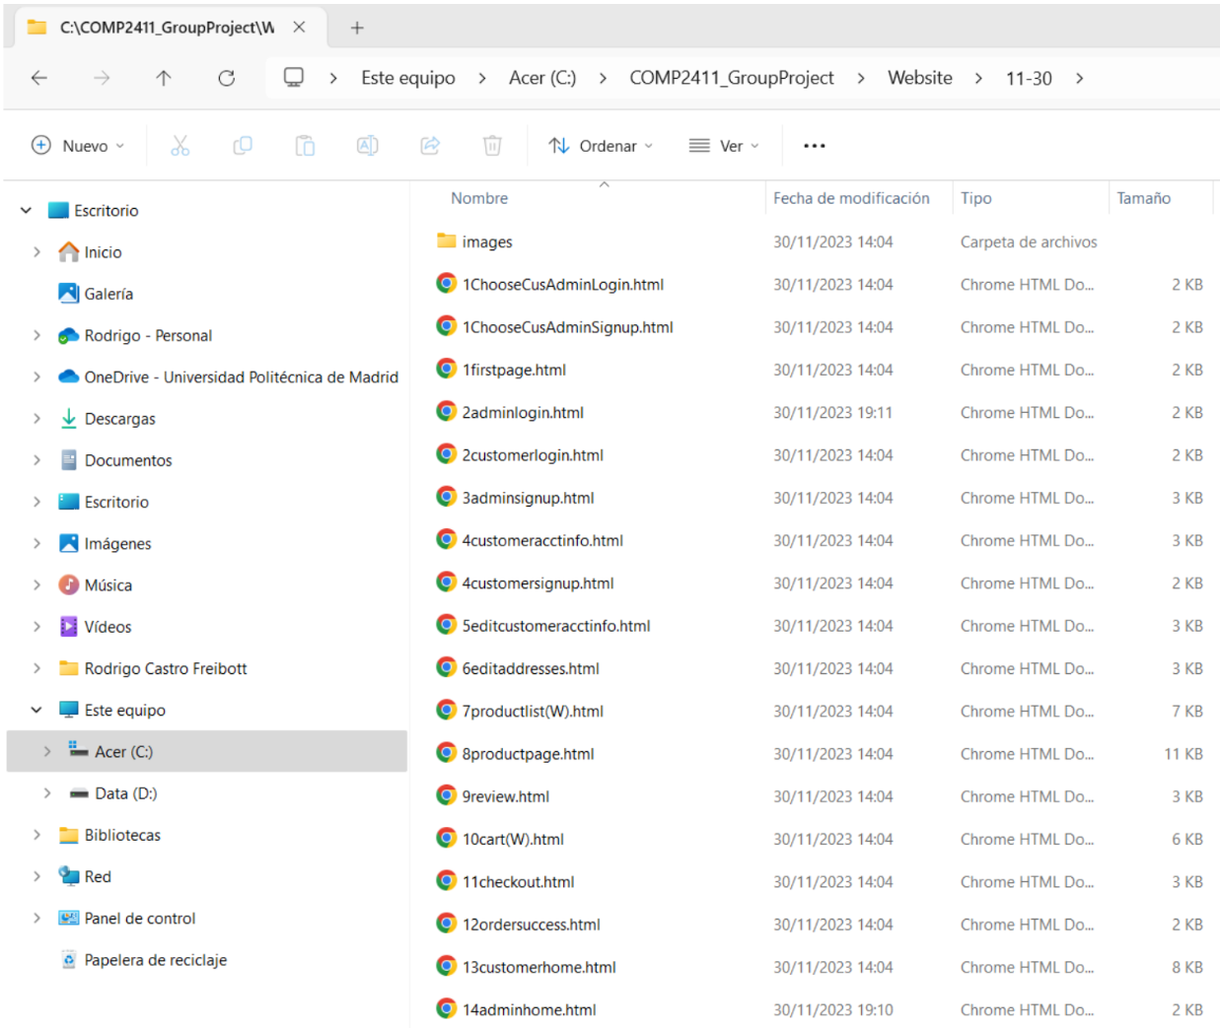

The picture above is an example of the source code file stored in “C:\COMP2411_GroupProject\Website\11-30”.

## Open cmd

Click Window + S. Then type “cmd” and press enter. You will open a cmd window.

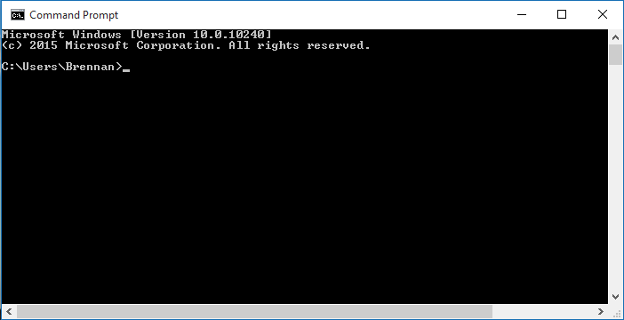

Cmd is the above dark window.

## Connect to the Linux server in your cmd

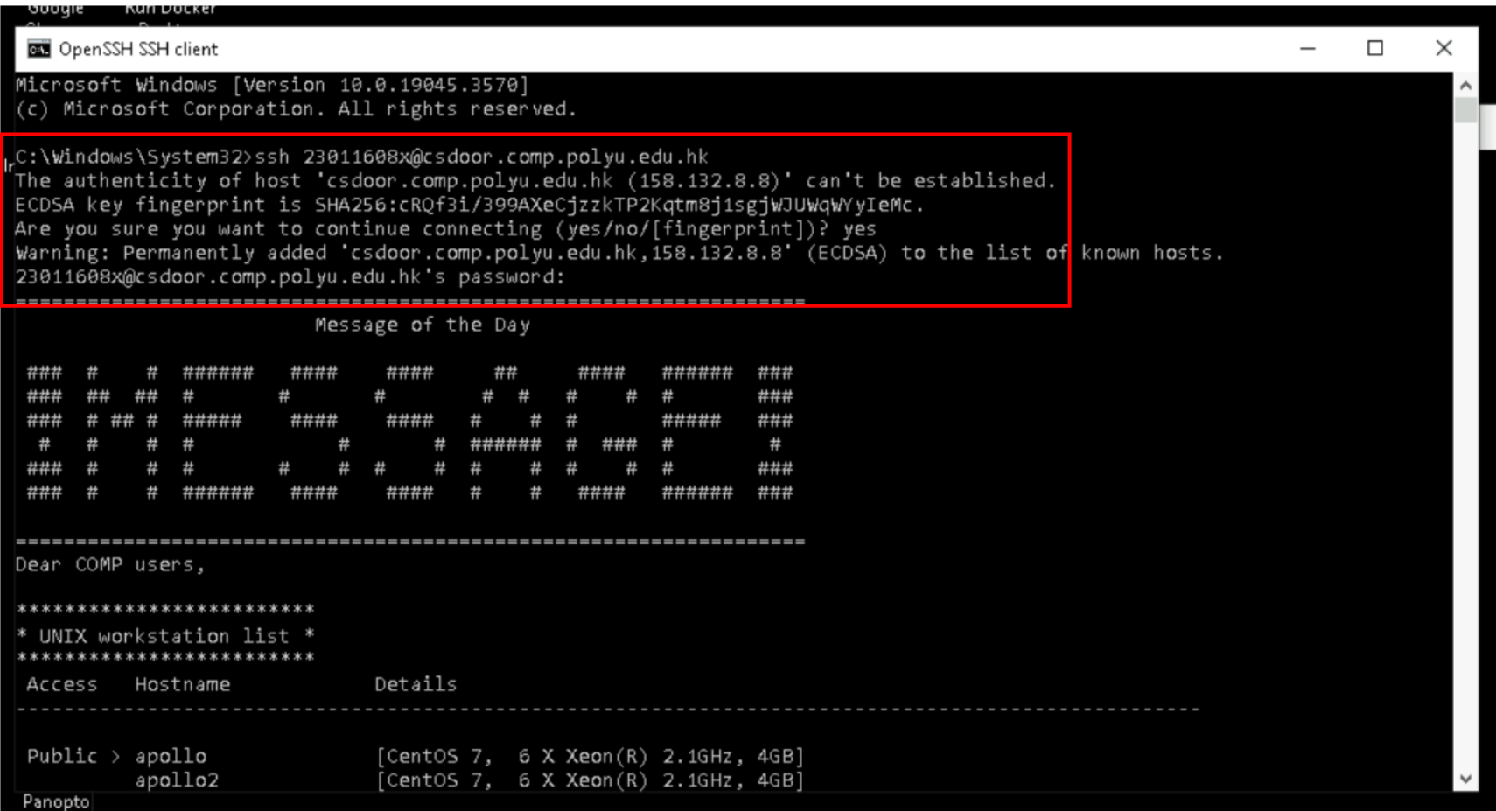

Type “ssh Your_ID@csdoor.comp.polyu.edu.hk”. Type “yes” if prompted to do so and then type your password.

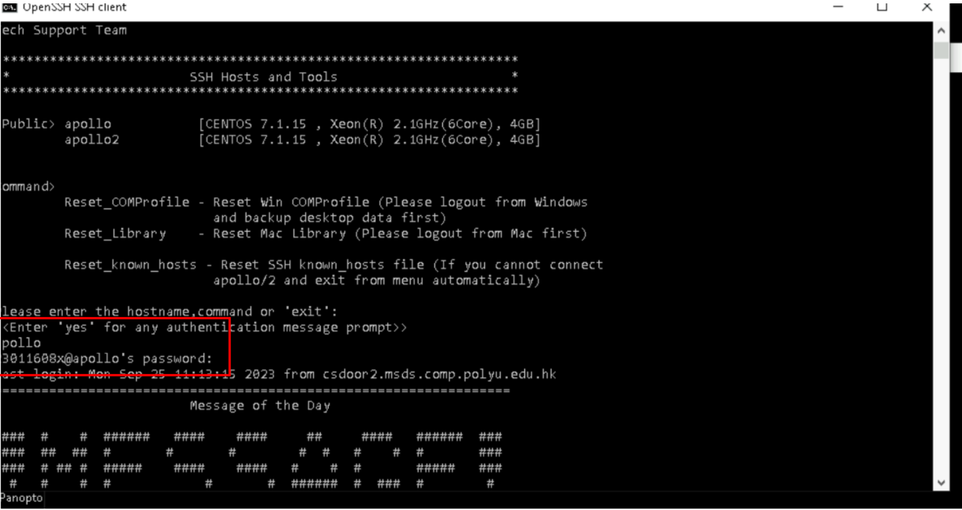

Type “apollo” or “apollo2” and then type your password.

## Create the public_html folder and make it executable for the other

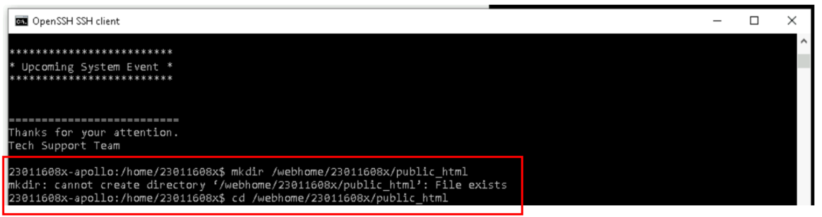

Create the folder by typing “mkdir /webhome/Your_ID/public_html”. If it already exists, go to the folder by typing “cd /webhome/Your_ID/public_html”. (*The instruction contains a space in the command. Pay attention.)

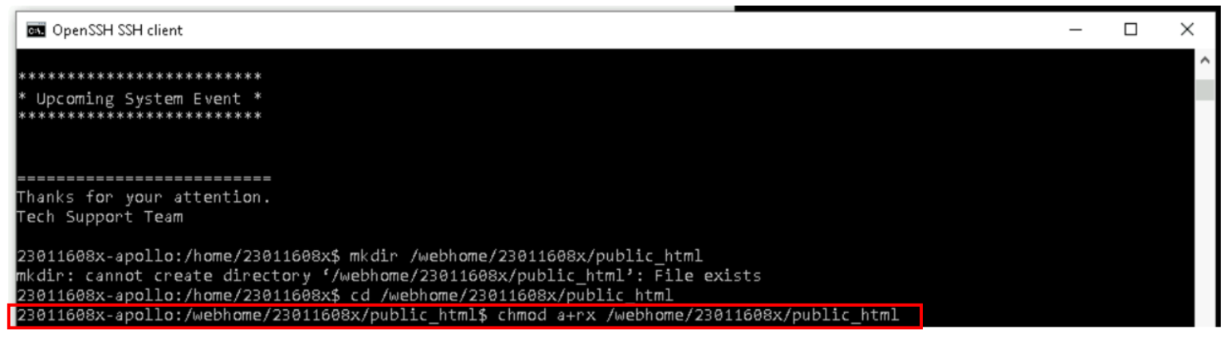

Make the folder executable for the others by typing “chmod a+rx /webhome/Your_ID/public_html”.

## Upload the HTML/PHP files to the Linux server

Without closing the cmd, open another cmd window by doing the same things as 2.2.

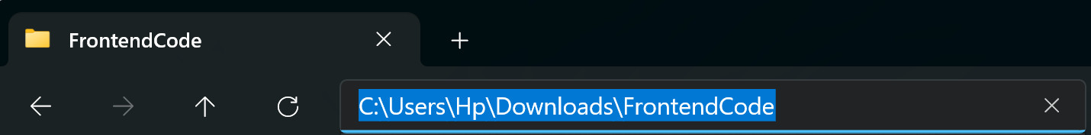

You can find your FrontendCode file location inside the FrontendCode folder in File Explorer by clicking the place shown in the above picture.

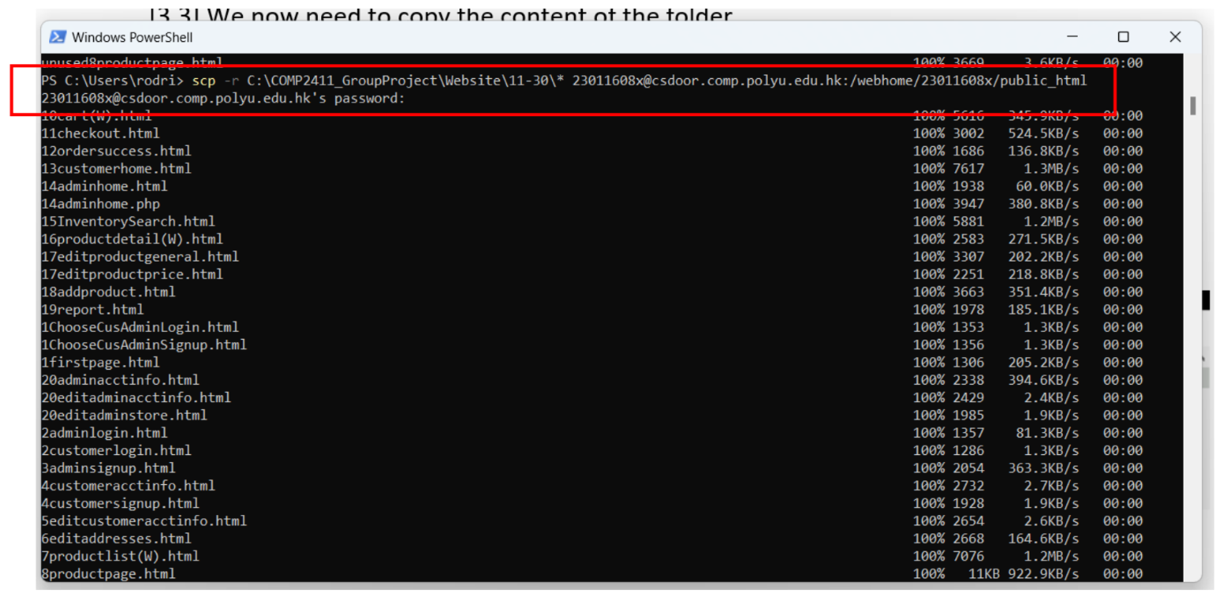

Pay attention after * have a space here. Type “scp -r Your FrontendCode file location\* Your_ID@csdoor.comp.polyu.edu.hk:/webhome/Your_ID/public_html” and then type your password. You can close this window.

## Check files

Go back to the cmd window we have in 2.4. Type “ls”.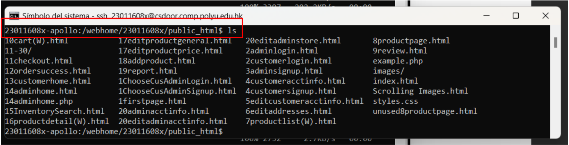

You will see the file inside the FrontendCode folder has been uploaded to the server. If not, redo from 2.1.

## Make HTML and PHP files readable to others



Make all your files readable to others by typing “chmod a+r *.html” and “chmod a+r *.php”.

## Run

Open a browser and type “http://www2.comp.polyu.edu.hk/~Your_ID/1firstpage.html”

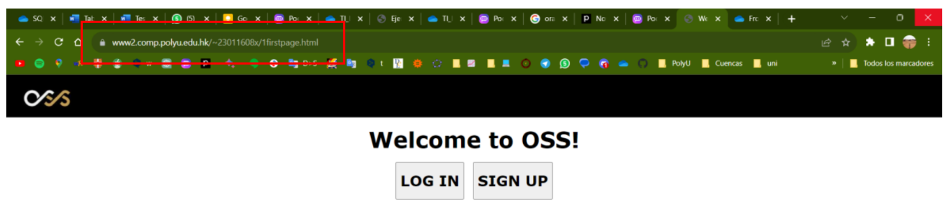

You will be able to see our OSS.

# Customer's views

## Main menu

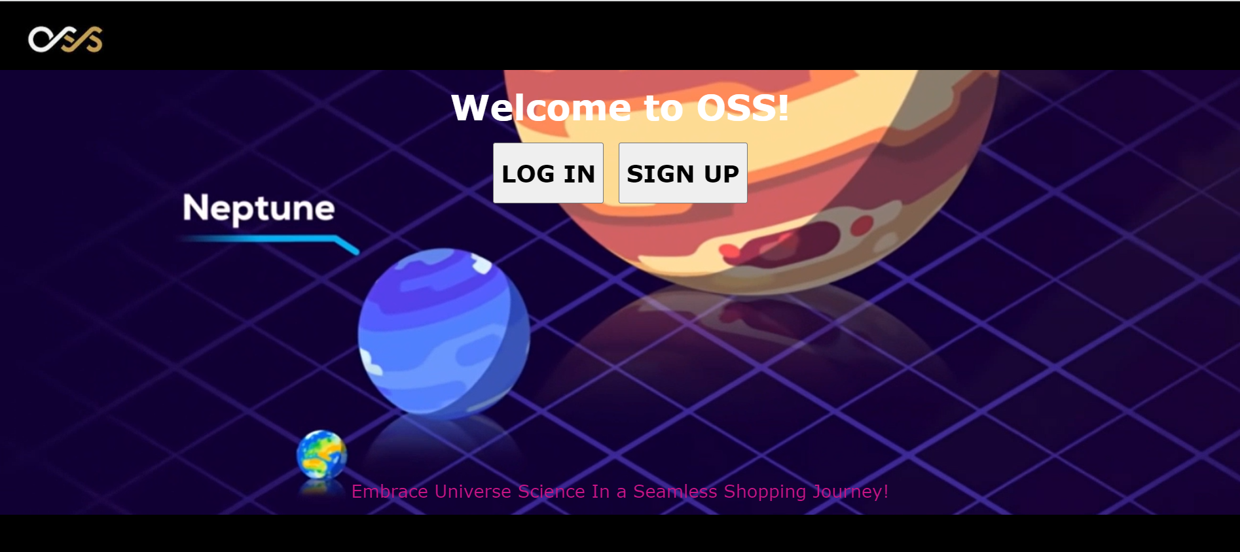

This is the main menu for our OSS. When the user enters our OSS, it will require the user to log in or sign up.



You can also scroll down to see the display of the slide show.

## Log in

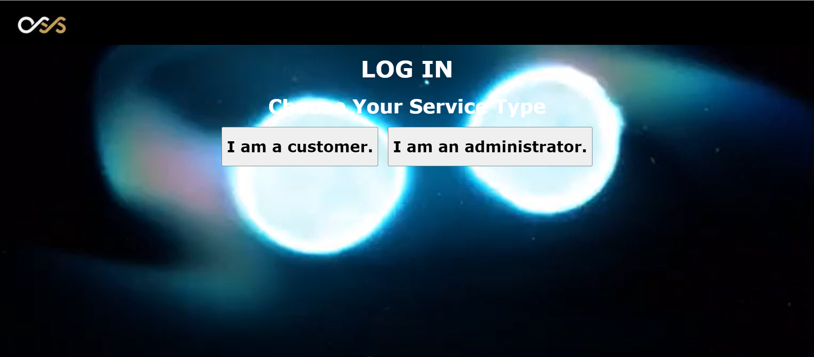

Click the login button and then click the "I am a customer" button.

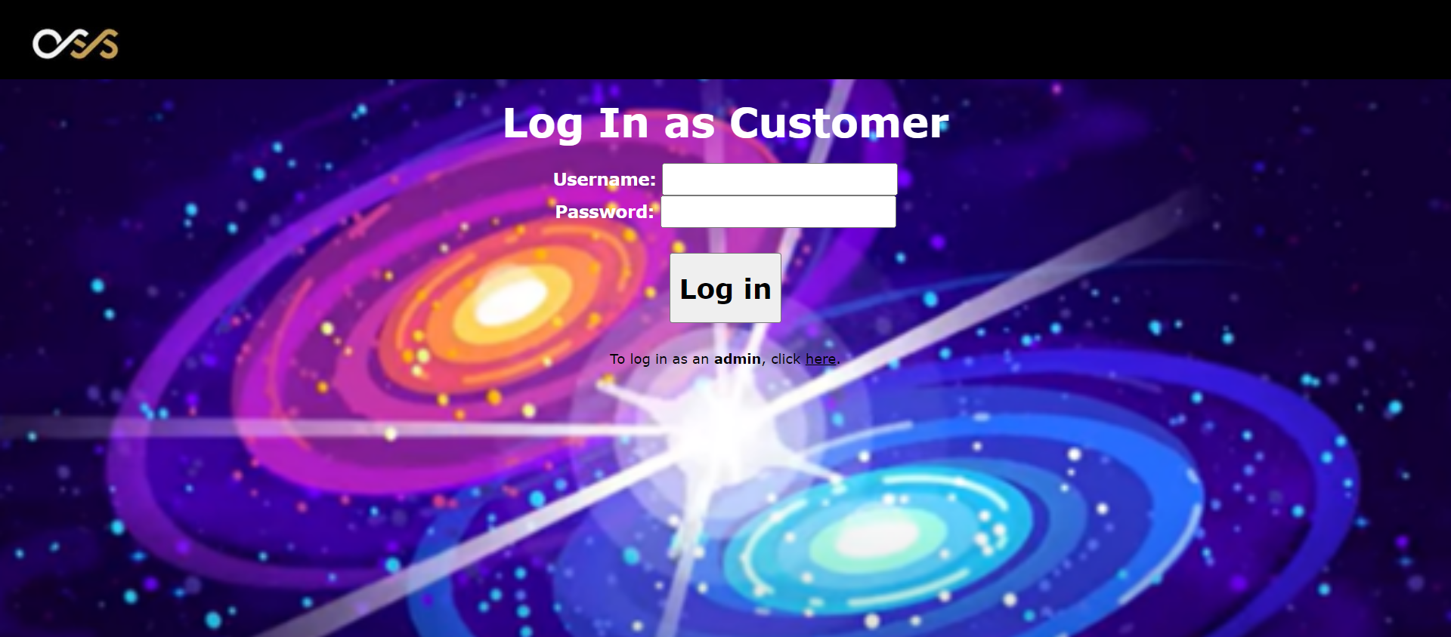

For a customer, enter the username and password. The customer can log in to the system if the username exists with the correct password. The user of the system also can click the "here" button change to log in with an administrator account.

## Sign up

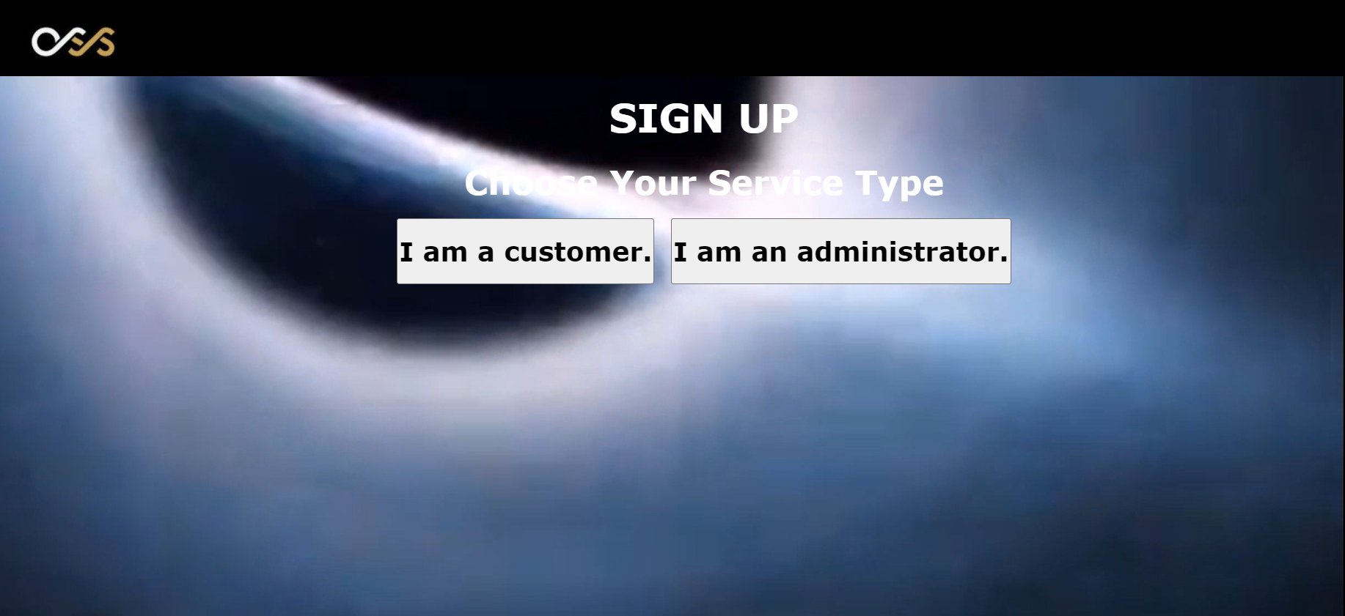

Click the sign-up button and then click the "I am a customer" button.

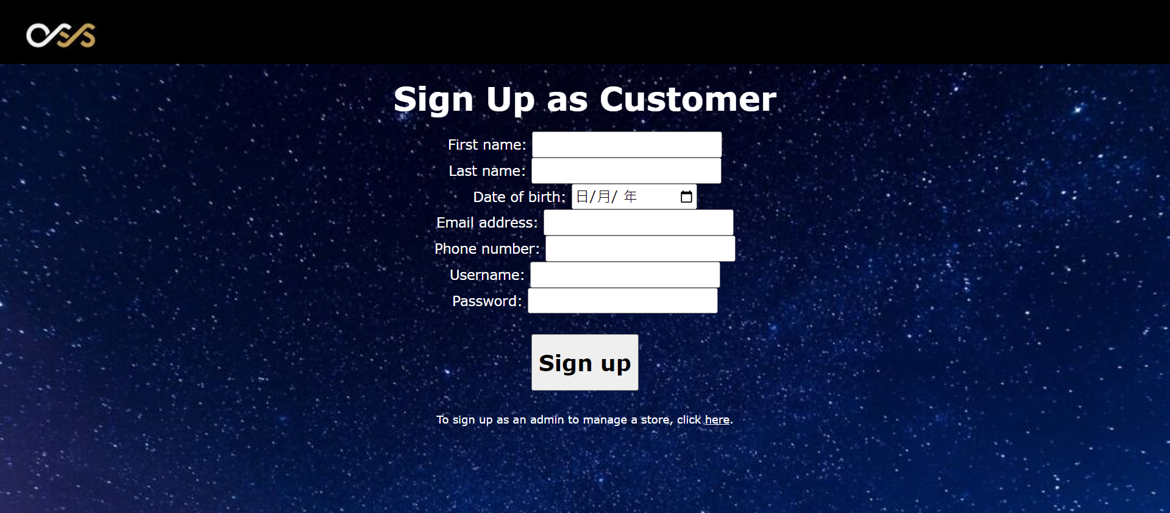

For a customer, enter the information shown in the above picture. Accounts can be successfully created if the information is valid. For example, if the username does not already exist in the system. Also, the user of the system can click the "here" button change to sign up with an administrator account.

## Customer home page

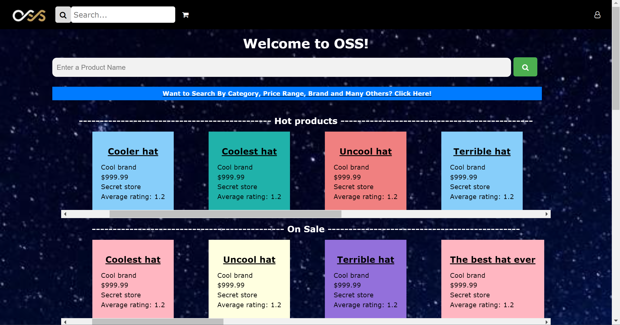

The above picture shows the home page of the customer. It will be displayed when the customer logs in to the system.

## Sign-out

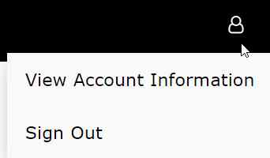

Put the mouse on the icon and click the "Sign Out" button to sign out. It will return to the main menu.

## Edit Personal Information



Put the mouse on the icon and click the "View Account Information" button.

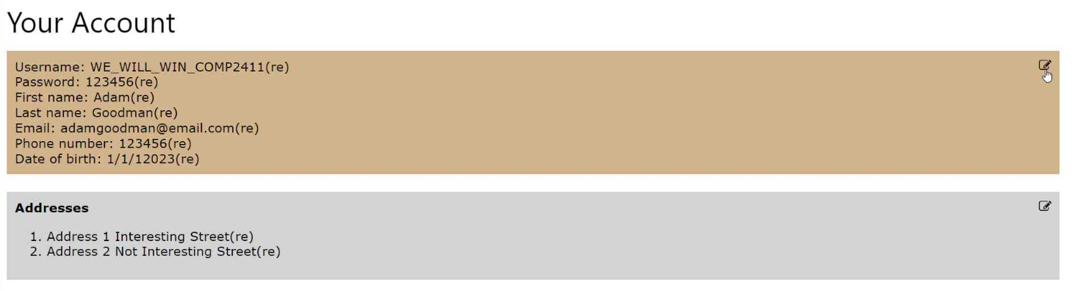

Click the pen icon inside the brown region.

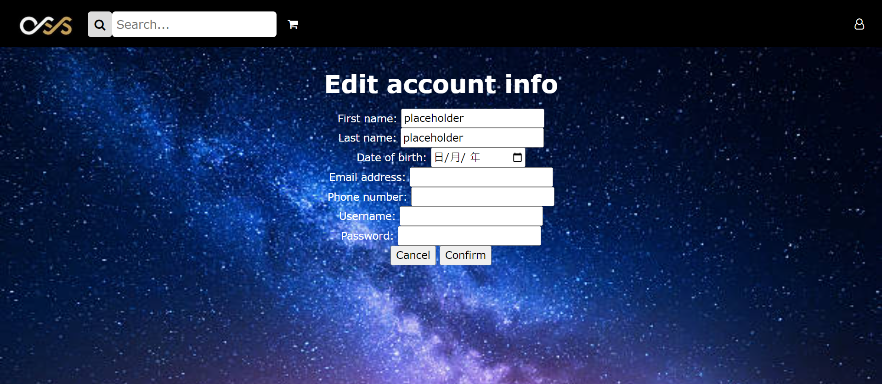

Then, input the new account information and click the confirm button to edit personal information or click cancel back to the last page.

## Edit addresses



Put the mouse on the icon and click the "View Account Information" button.

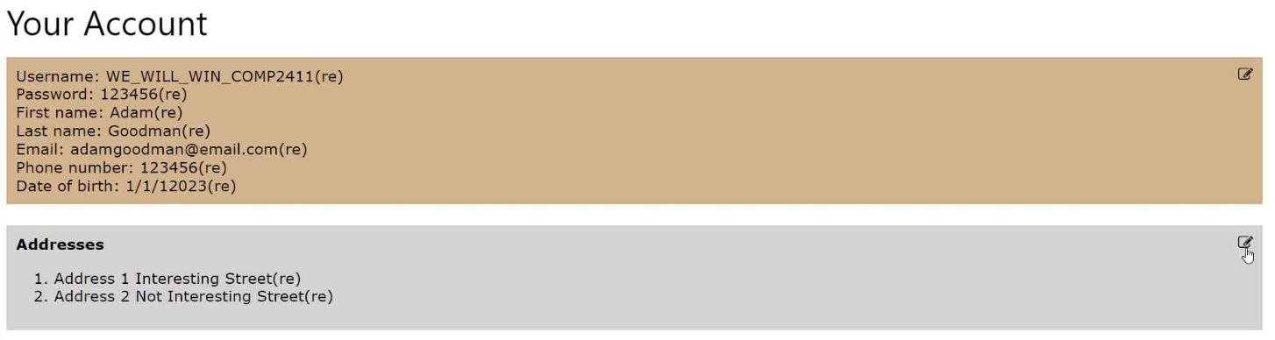

Click the pen icon inside the grey region.

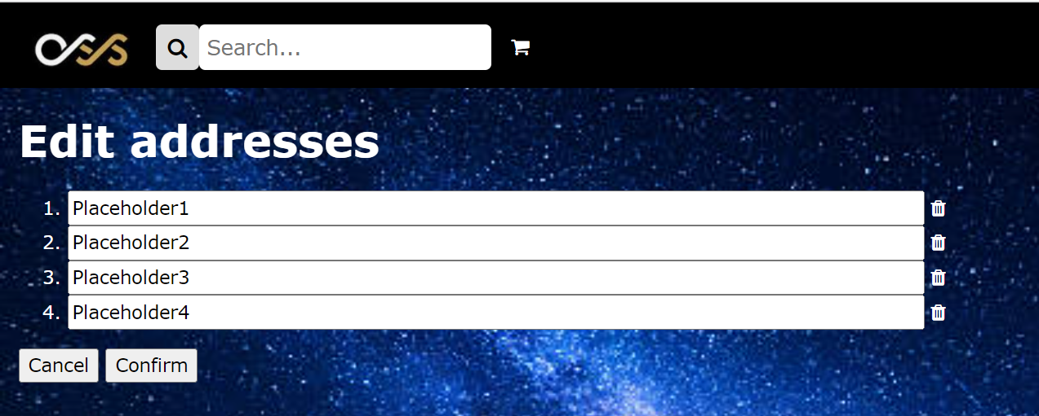

Input the new address inside the text field or click the rubbish bin icon to delete the address. Then, click confirm to make a change or click cancel back to the last page.

## Search product (not finished)

You can search for a product by filter.

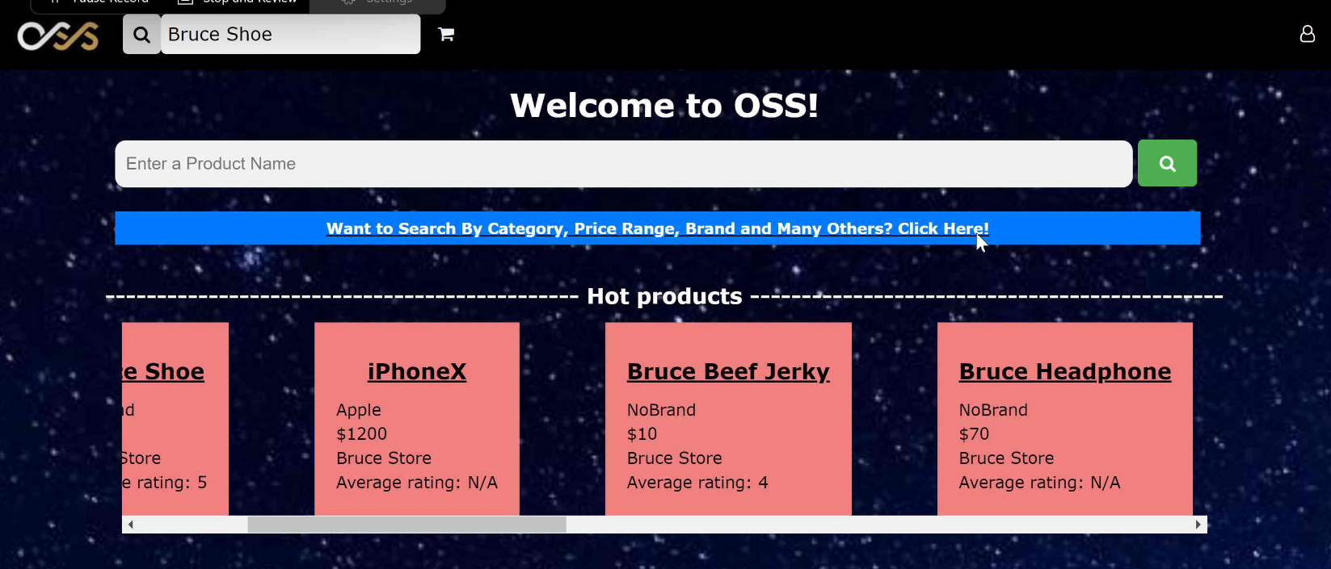

Click the “Click here” button.

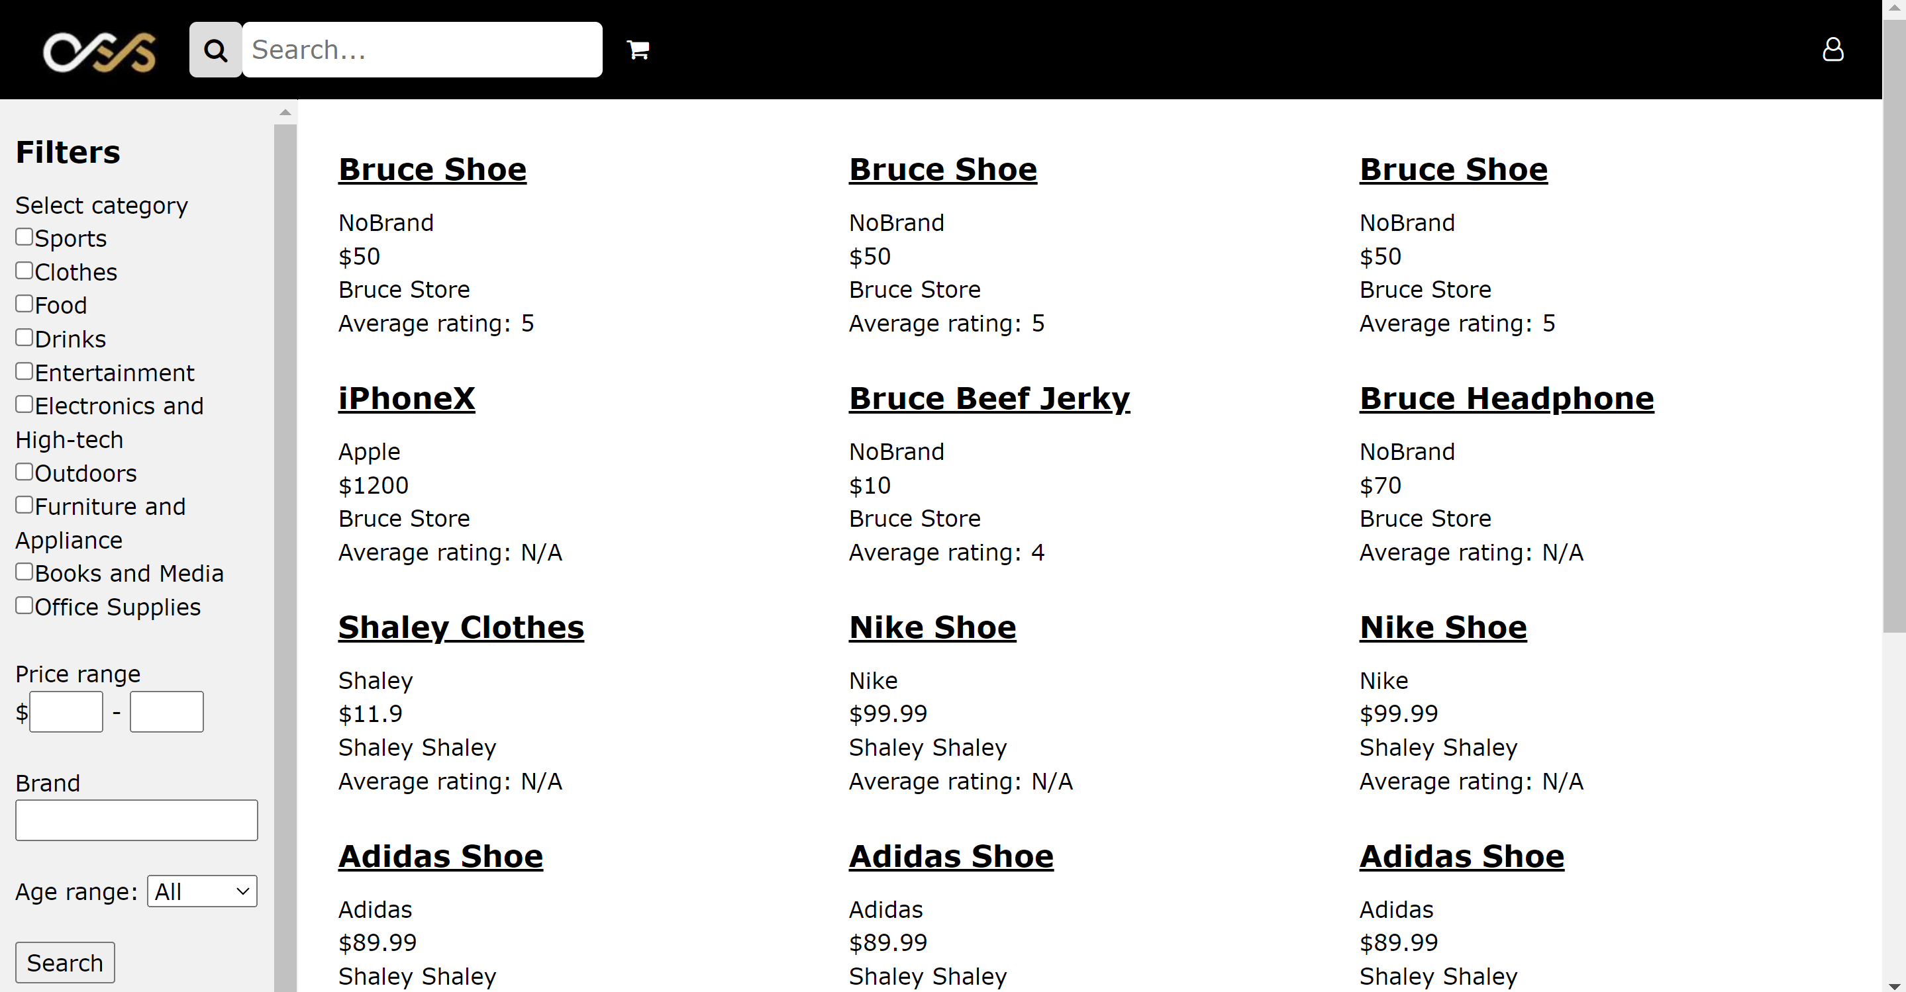

You will be able to see the list of products inside our OSS.

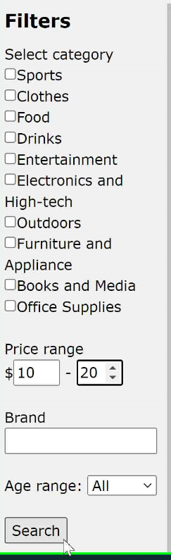

You can search for the product by the filter on the left-hand side. Here is an example of searching for a product with a price range between 10 and 20.

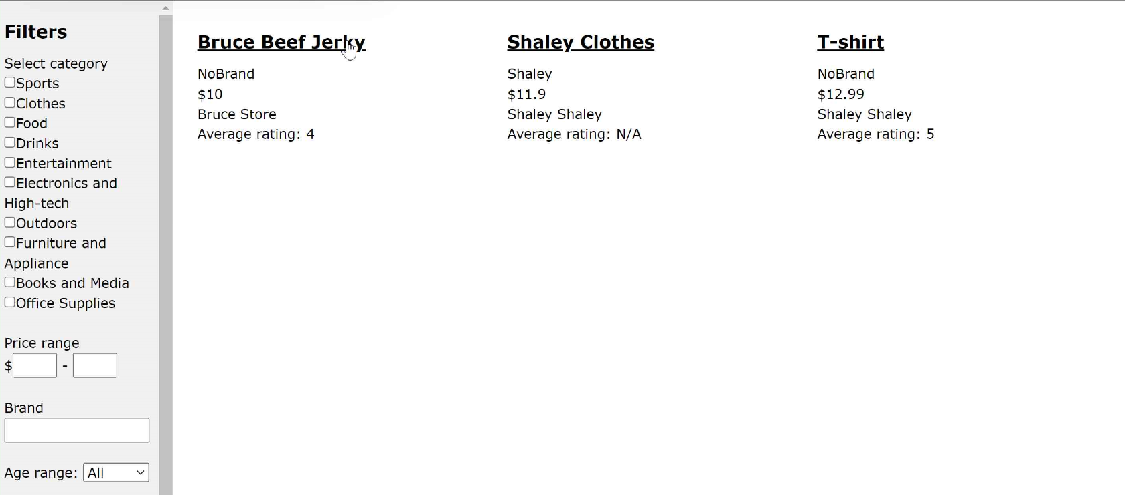

After executing, you will be able to see all products have prices inside this range.

## Product detail

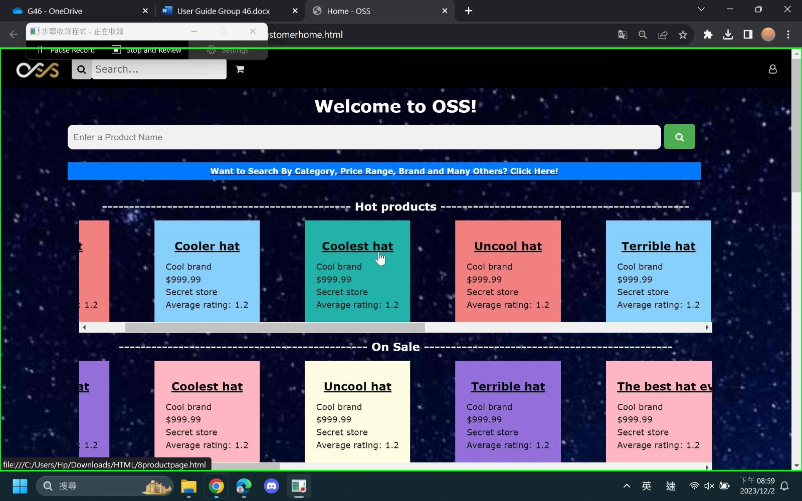

Customers can click on the name of the product on the homepage or the page inside 3.8.

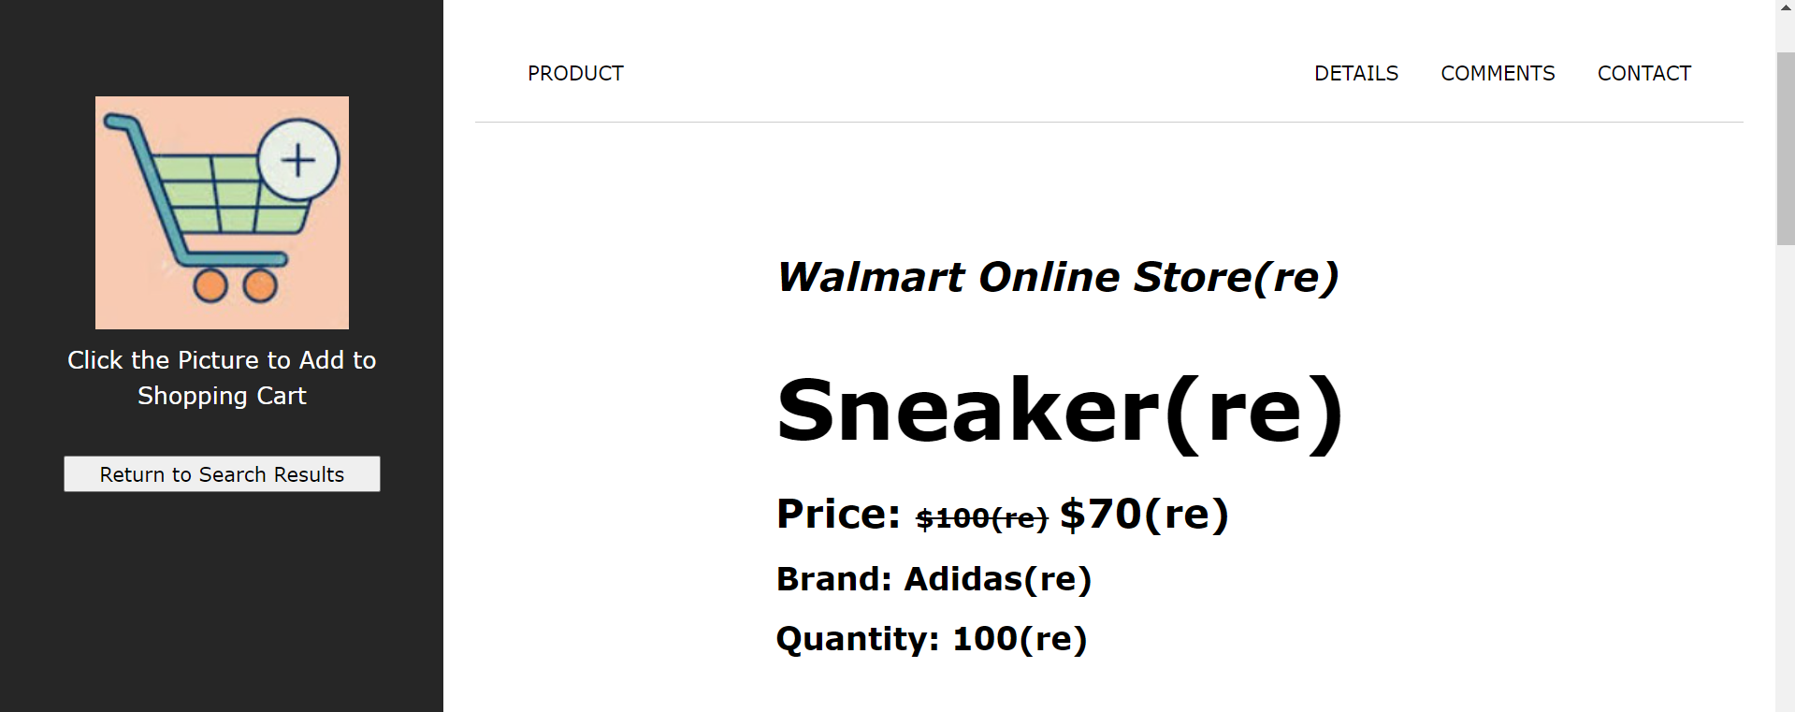

Then, the system will display the details of this product including the details, comments by another user and contact of the store of this product.

## Shopping Cart



Click the shopping cart icon.

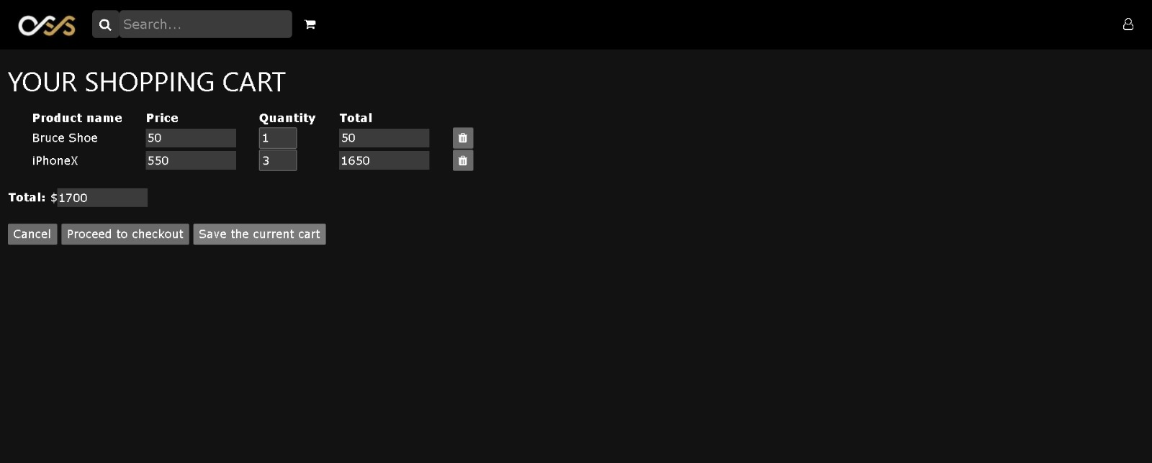

Then, our system will display the details of products that customers put into the shopping cart.

## Checkout

Inside the Shopping Cart in 3.10, 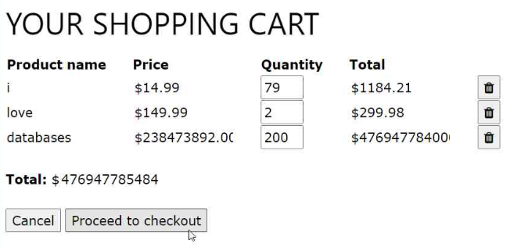

Users can click the "Proceed to checkout" button to checkout.

Our system will show you the shipping address that exists in this account and the payment method that exists in the system. Choose the shipping address and payment method and then click confirm to checkout or click cancel back to the last page.



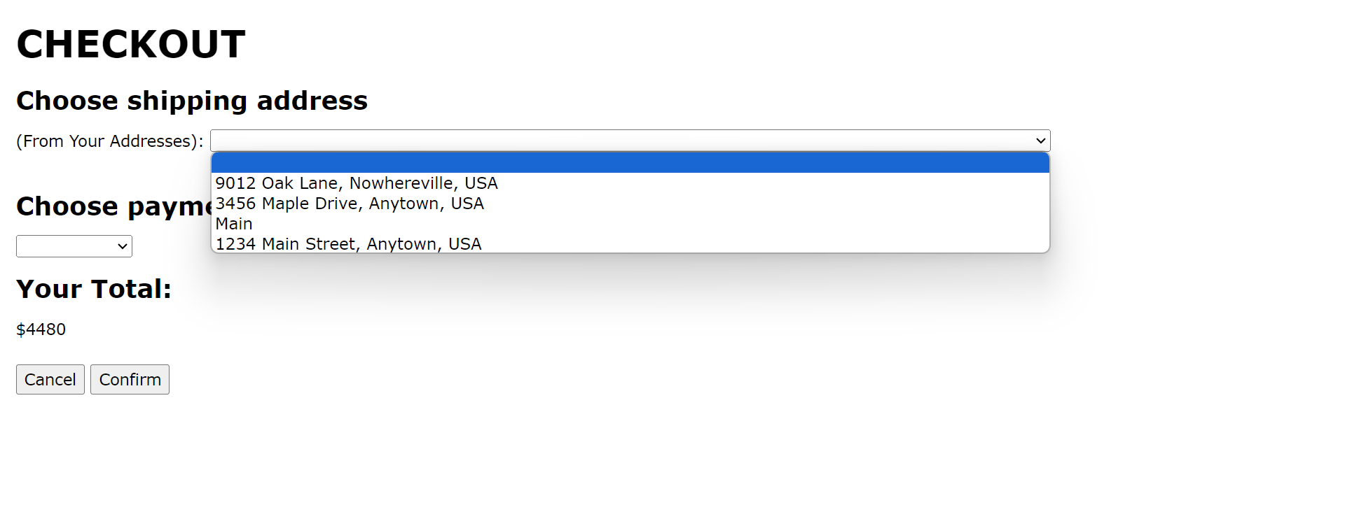

If your purchase is successful, the message “Your Purchase Is Successful!” will be shown in the OSS. Click the “Back to Main Page” button to go back to the customer homepage.

## Review system

Customers can give comments on the product. Inside the product detail page in 3.9,

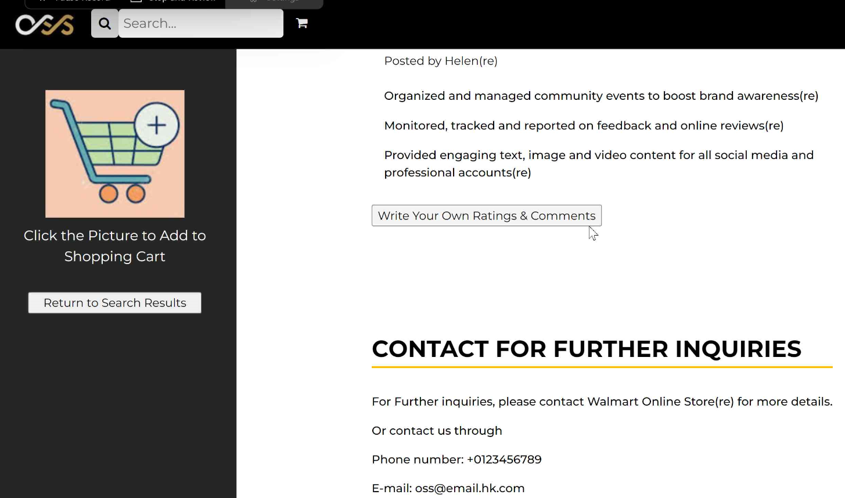

Click “Write Your Own Ratings & Comments”.

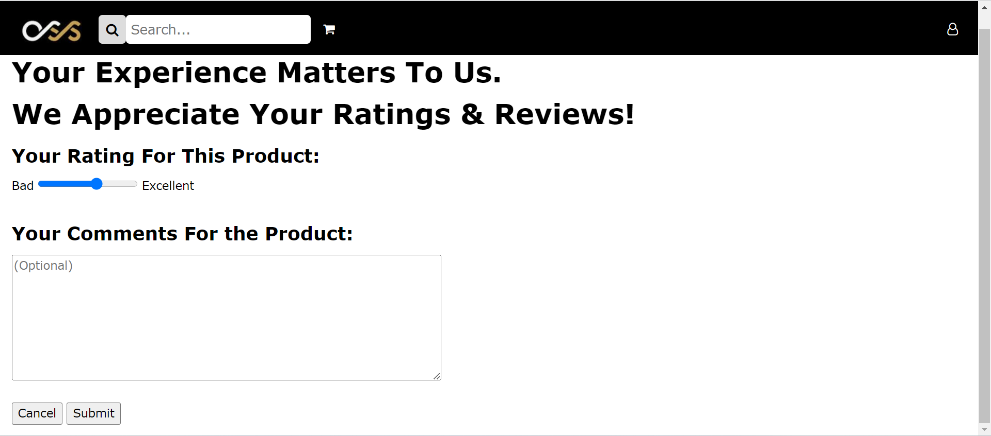

Click submit to submit the comments or click cancel back to the product detail page.

# Administrator's views

## Main menu

Same for 3.1.

## Login

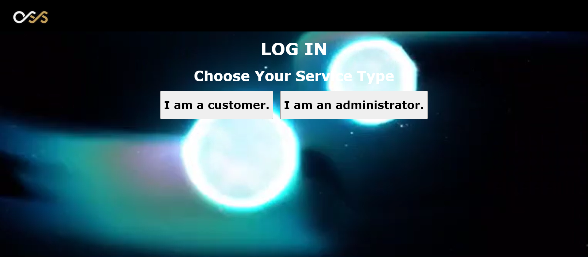

Click the login button and then click the "I am an administrator" button.

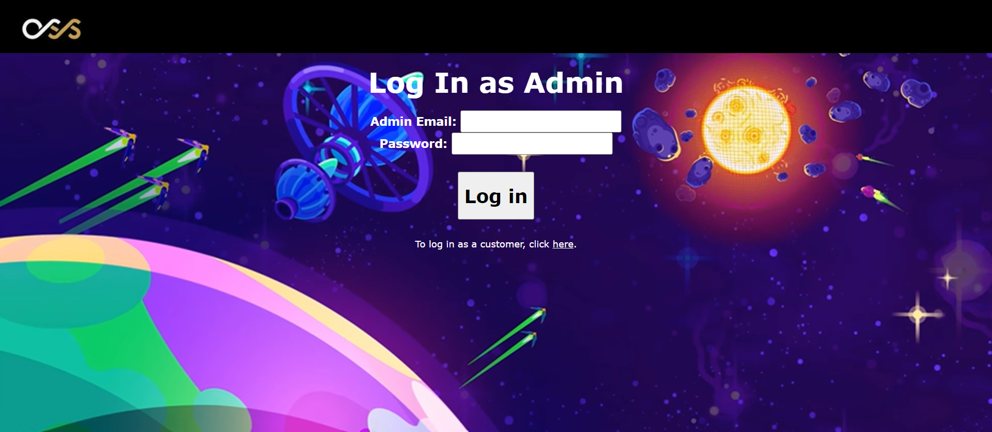

For an administrator, enter the Admin Email and password. The customer can log in to the system if the Admin Email exists with the correct password. The user of the system also can click the "here" button change to log in with a customer account.

## Sign up

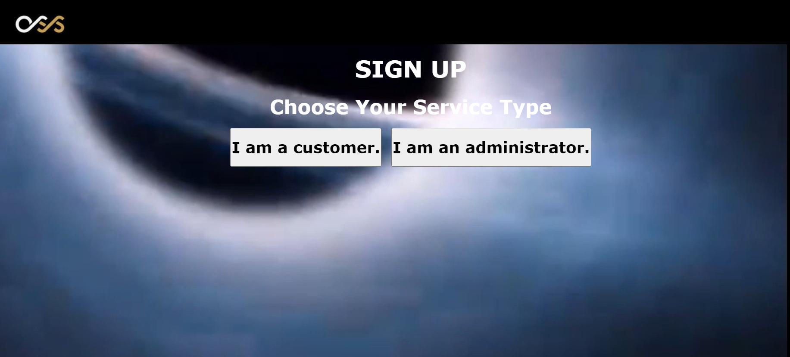

Click the sign-up button and then click the "I am an administrator" button.

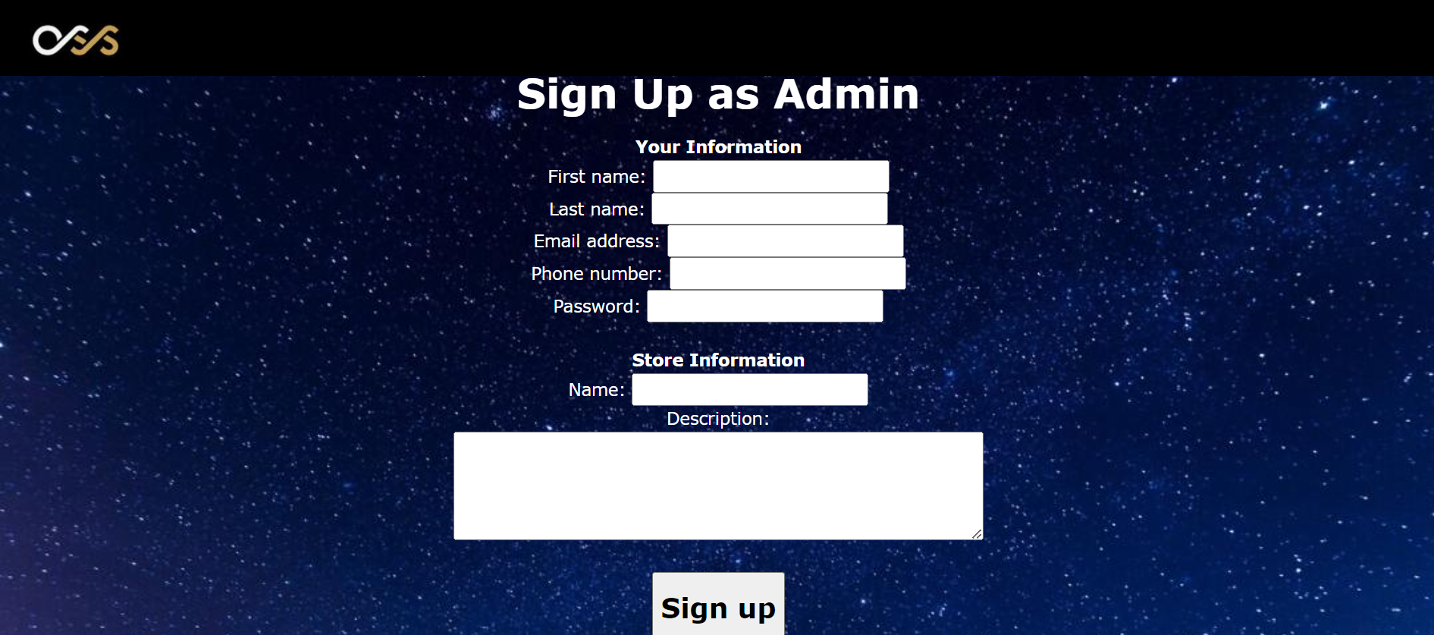

For an administrator, enter the information shown in the above picture. Accounts can be successfully created if the information is valid. For example, if that store already had an administrator, then that account cannot be created. Also, the user of the system can click the "here" button change to sign up with a customer account.

## Administrator home page

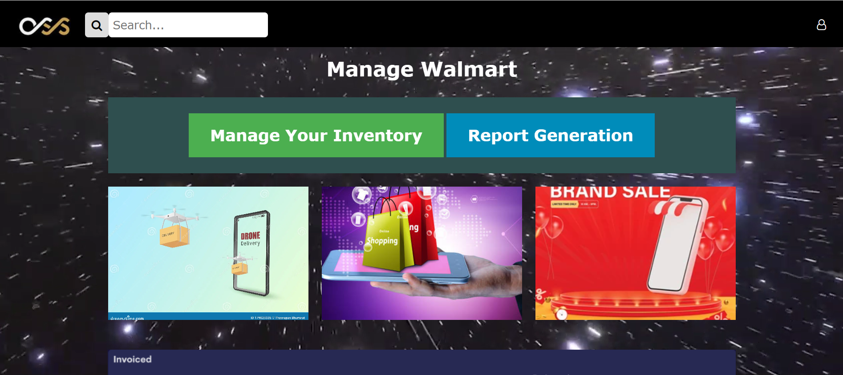

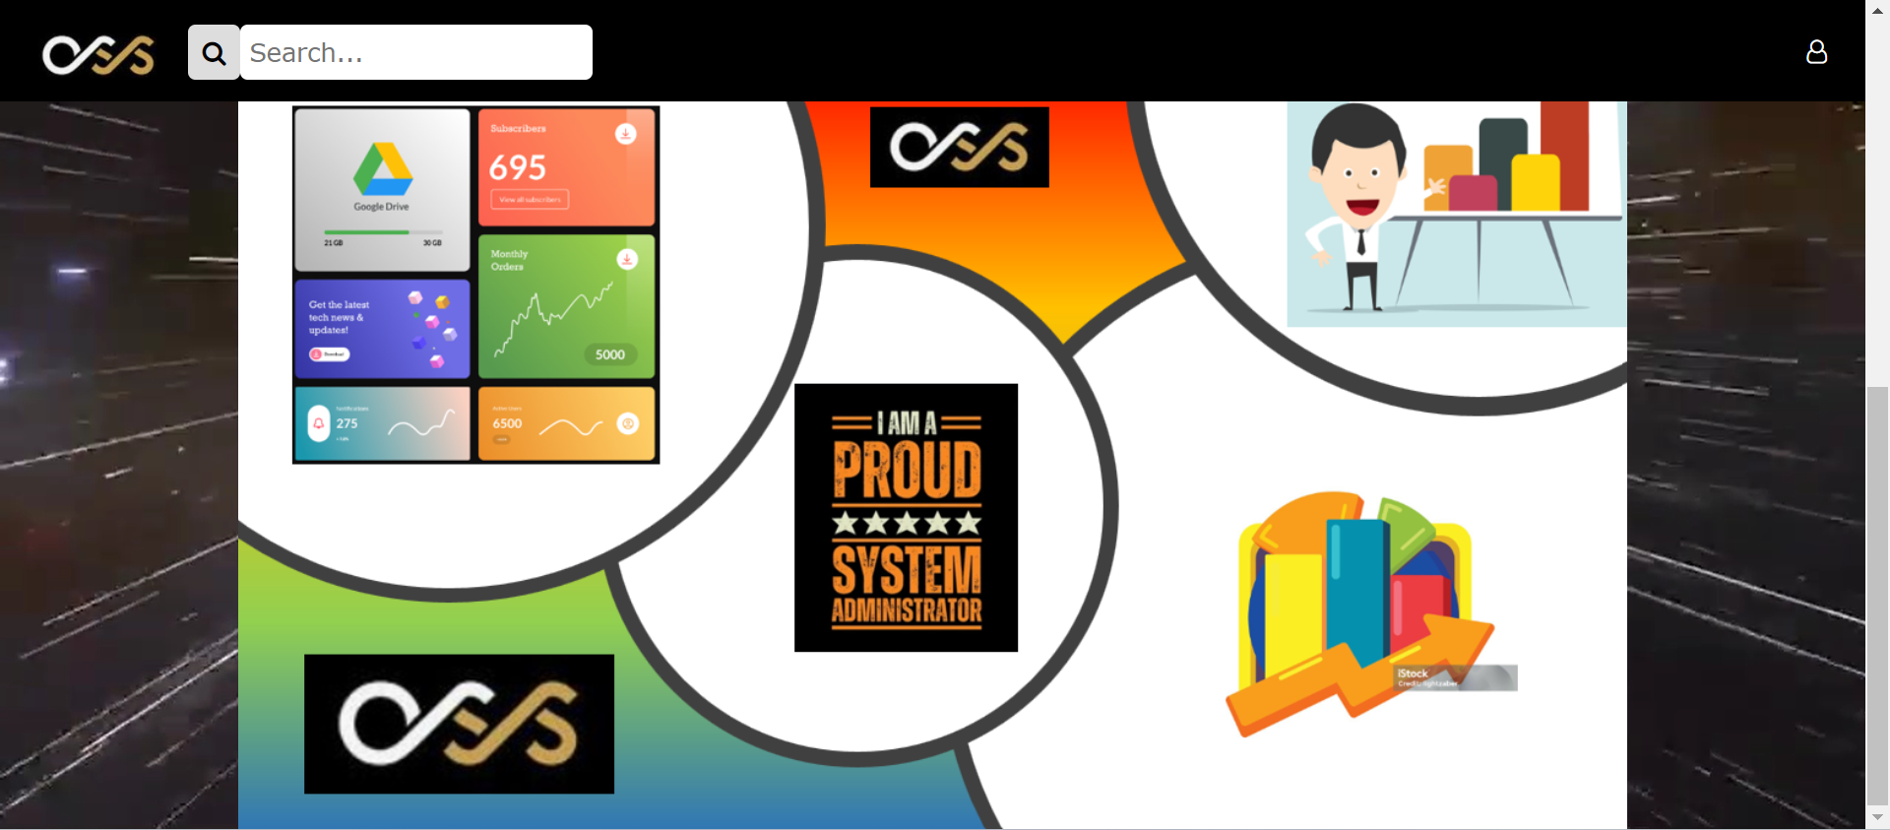

The above picture shows the home page of the administrator. It will be displayed when the administrator logs in to the system.

## Sign-out



Put the mouse on the icon and click the "Sign Out" button to sign out. It will return to the main menu.

## Edit personal information



Put the mouse on the icon and click the "View Account Information" button.

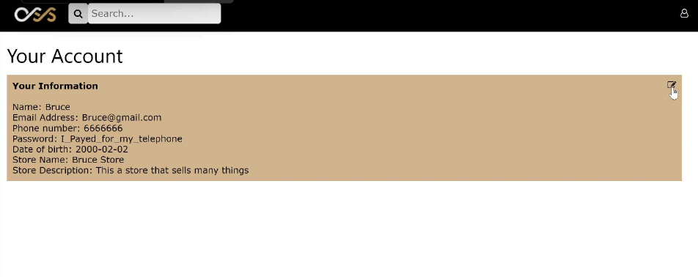

Click the pen icon inside the brown region.

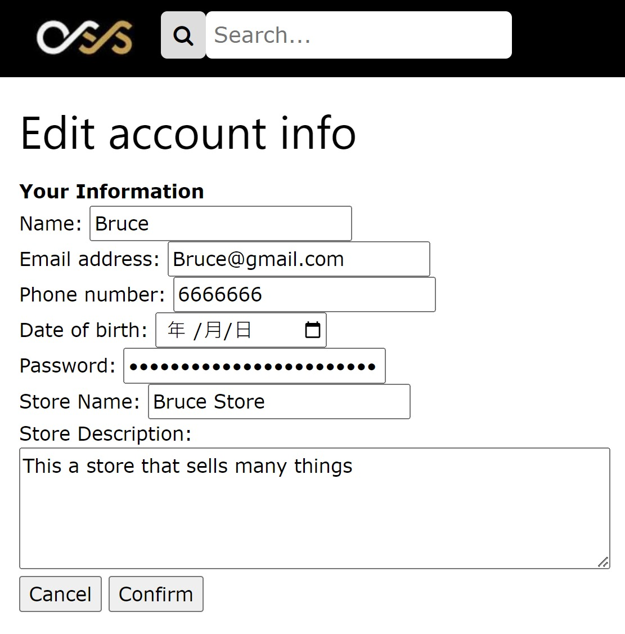

Then, input the new account information and click the confirm button to edit personal information or click cancel back to the last page.

## Edit store information



Put the mouse on the icon and click the "View Account Information" button.



Click the pen icon inside the grey region.

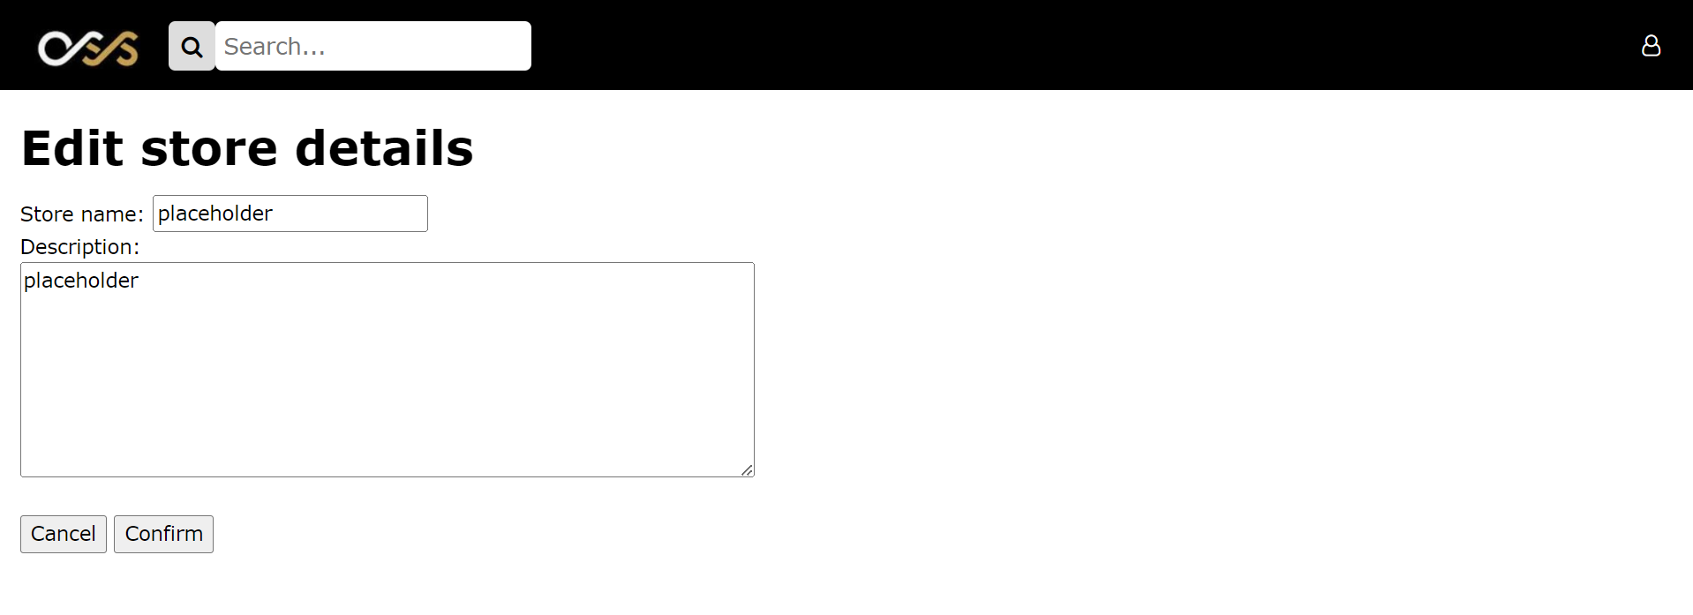

Input the new information about the store and click confirm to make a change or click cancel back to the last page.

## Find product list in administrator store

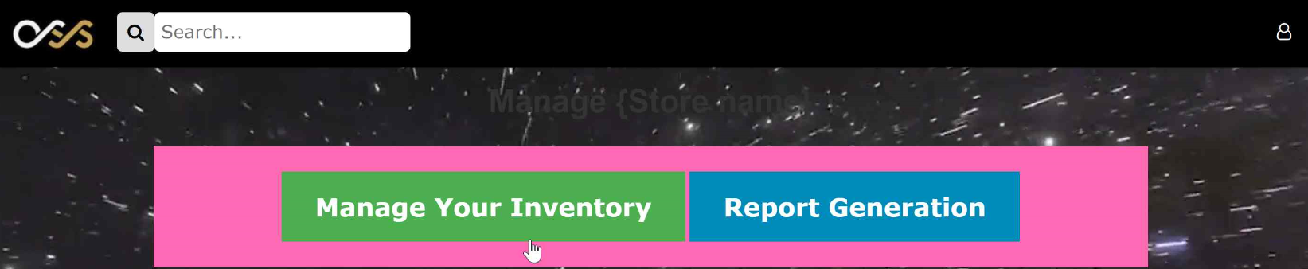

Click “Manage Your Inventory” on the administrator homepage.

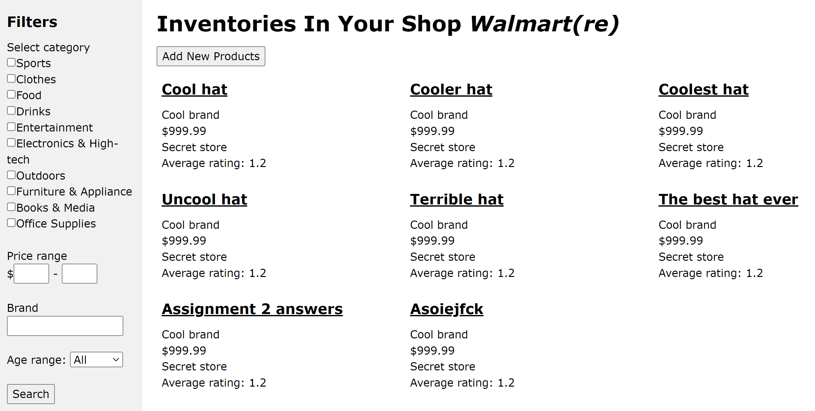

Then, it will display all the products inside this administrator store and their details.

## Edit Product Information

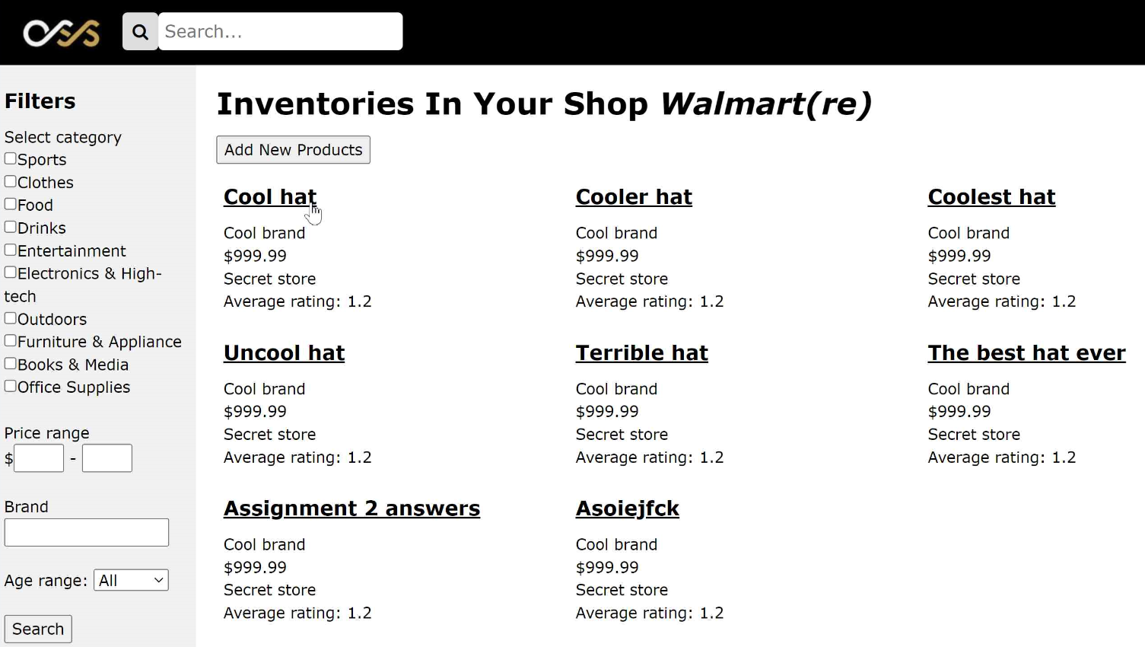

Click the product name you want to edit on page 4.8.

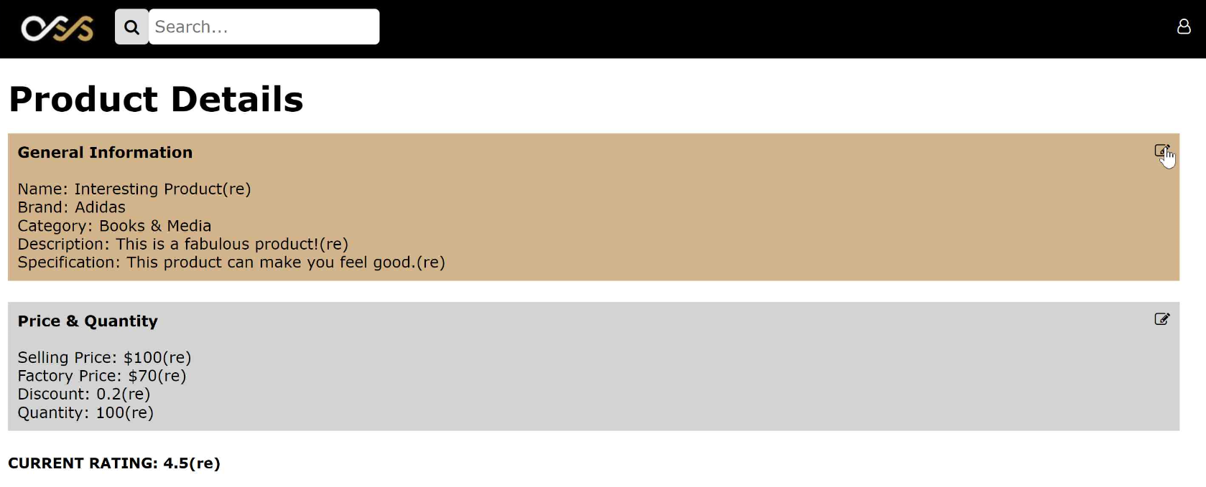

Click the pen icon in the brown region.

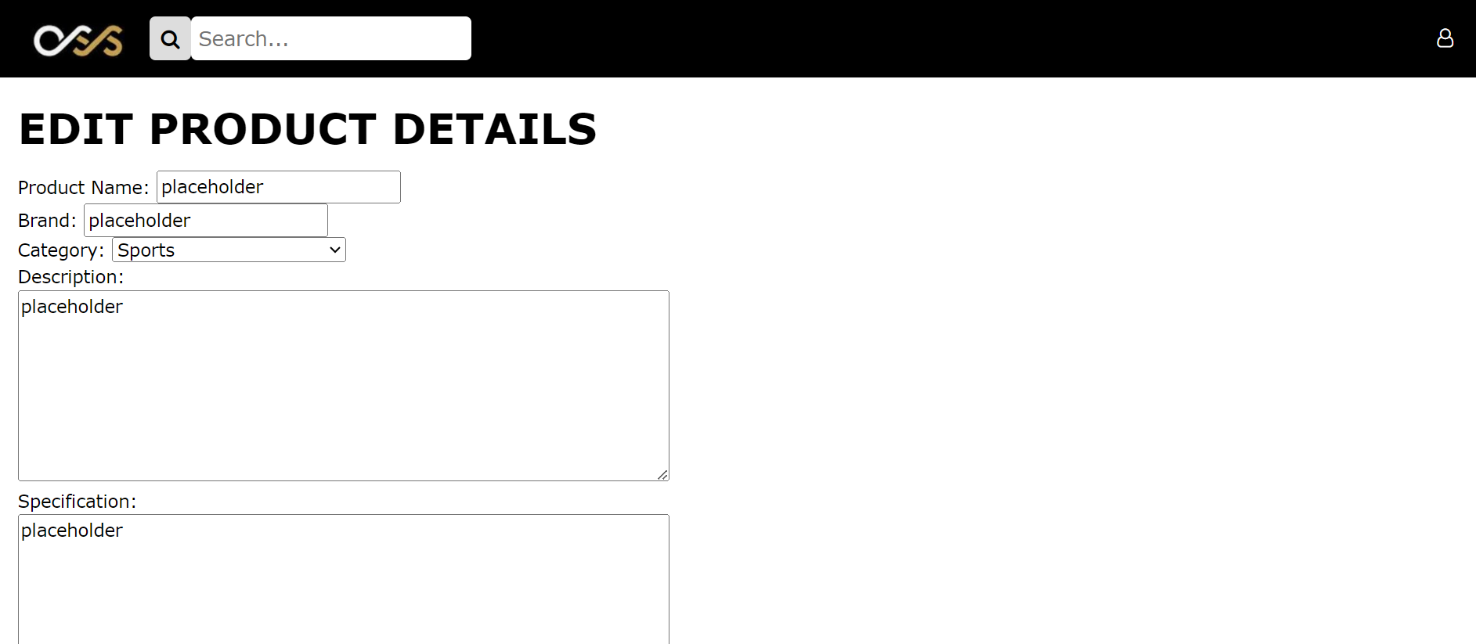

Edit and change the information of the product by clicking the “Confirm” button or press Cancel back to the last page.

## Edit product price and quantity



Click the product name you want to edit on page 4.8.

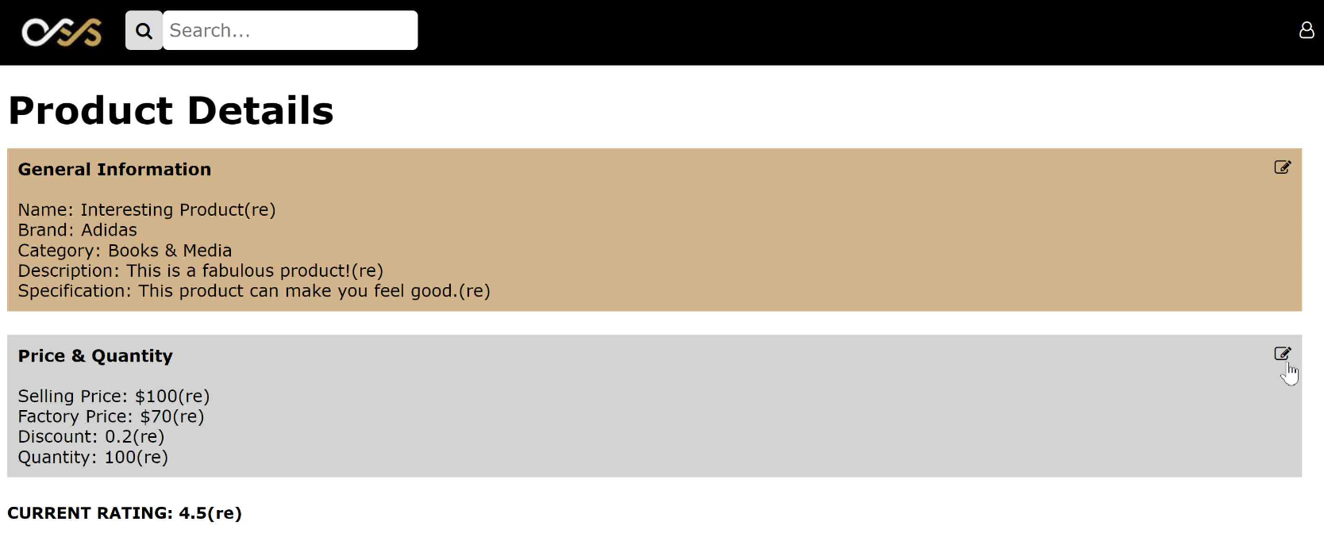

Click the pen icon in the grey region.

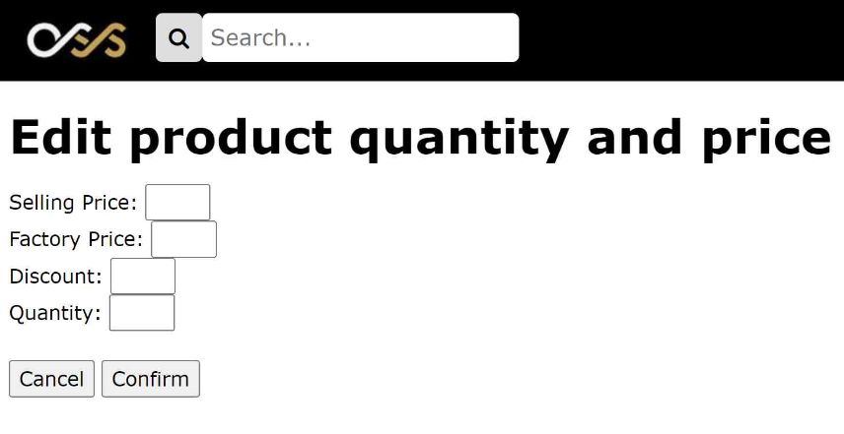

Edit and change the product quantity and price by clicking the “Confirm” button or press Cancel back to the last page.

## Add product to the store

On page 4.8,

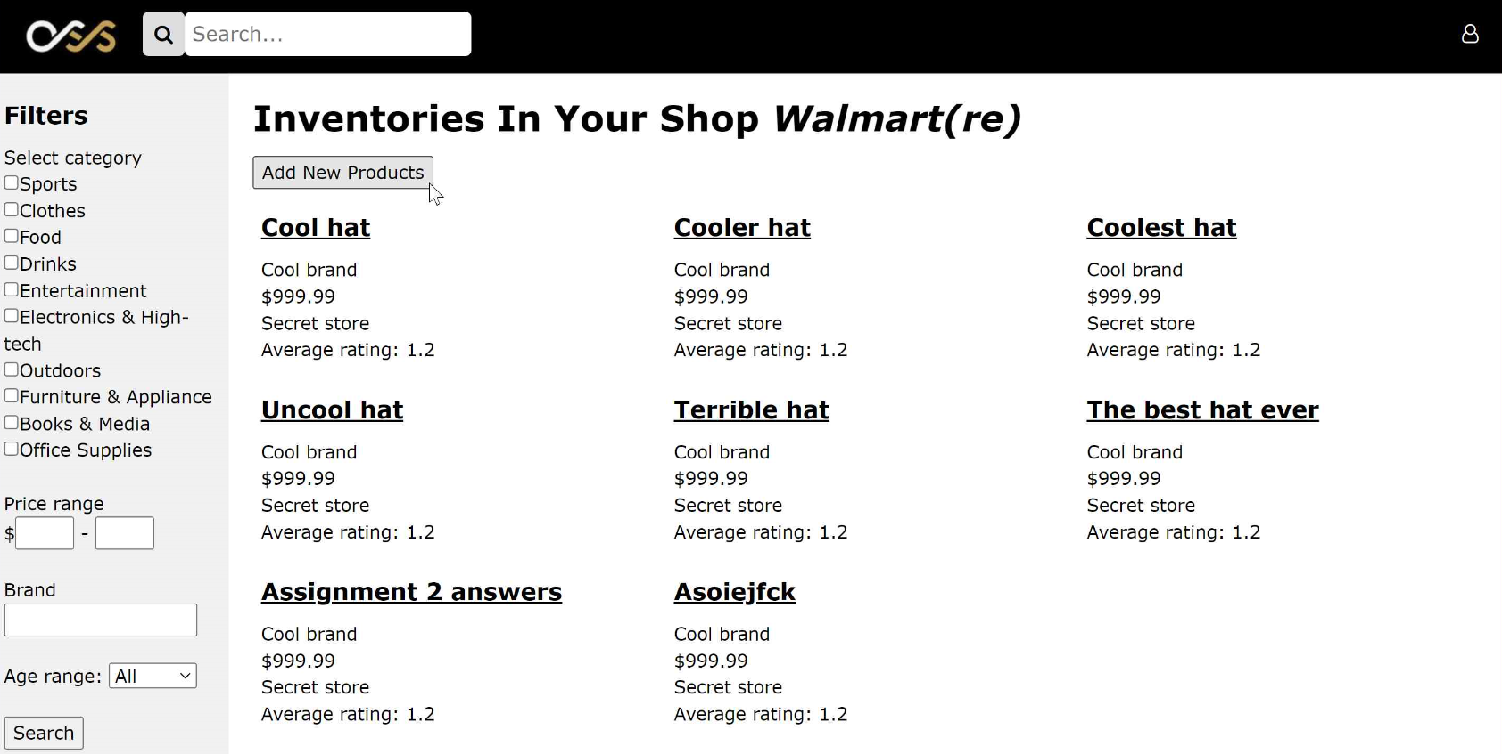

Click “Add New Products”.

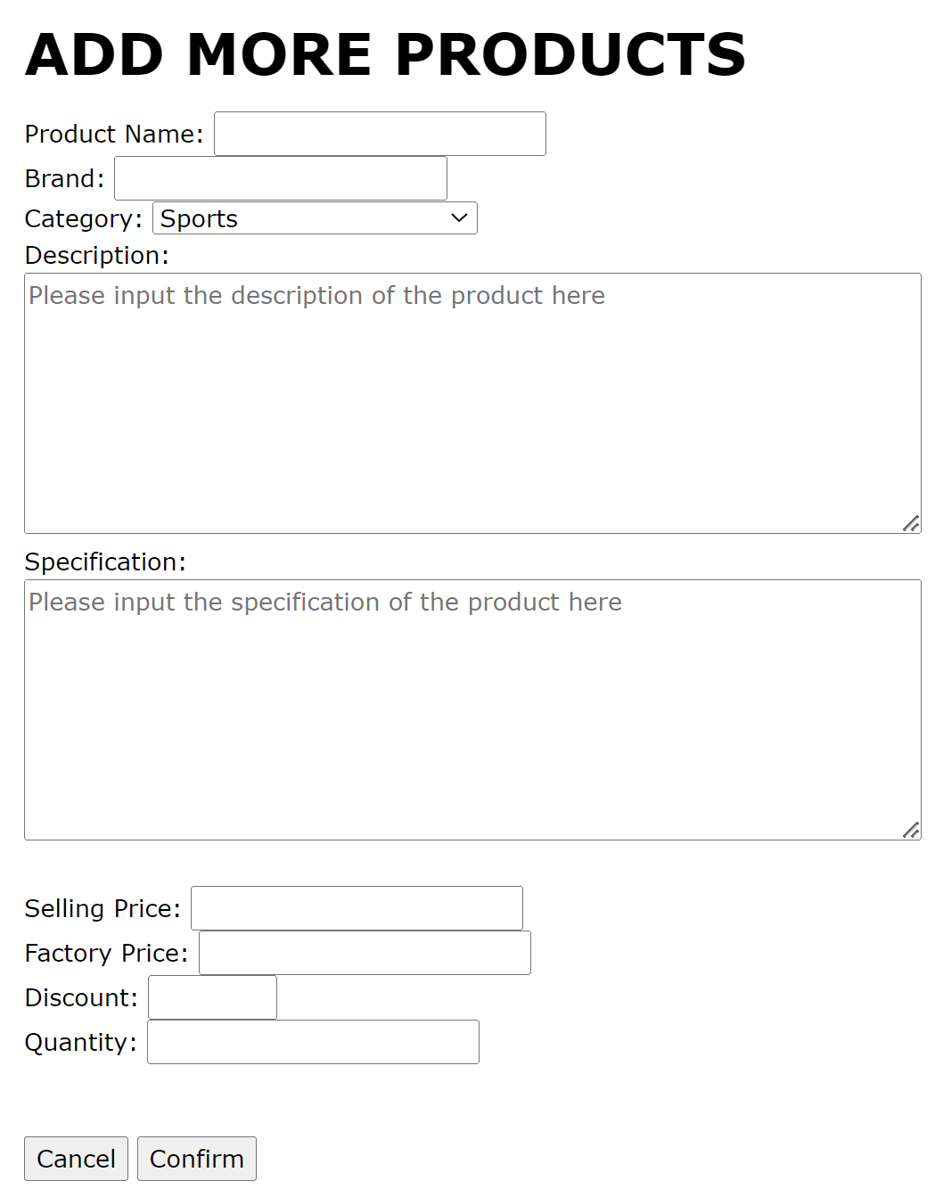

Write down the information about the new product and press “Confirm” to add a product to the store or click “Cancel” back to the last page.

## Report generation

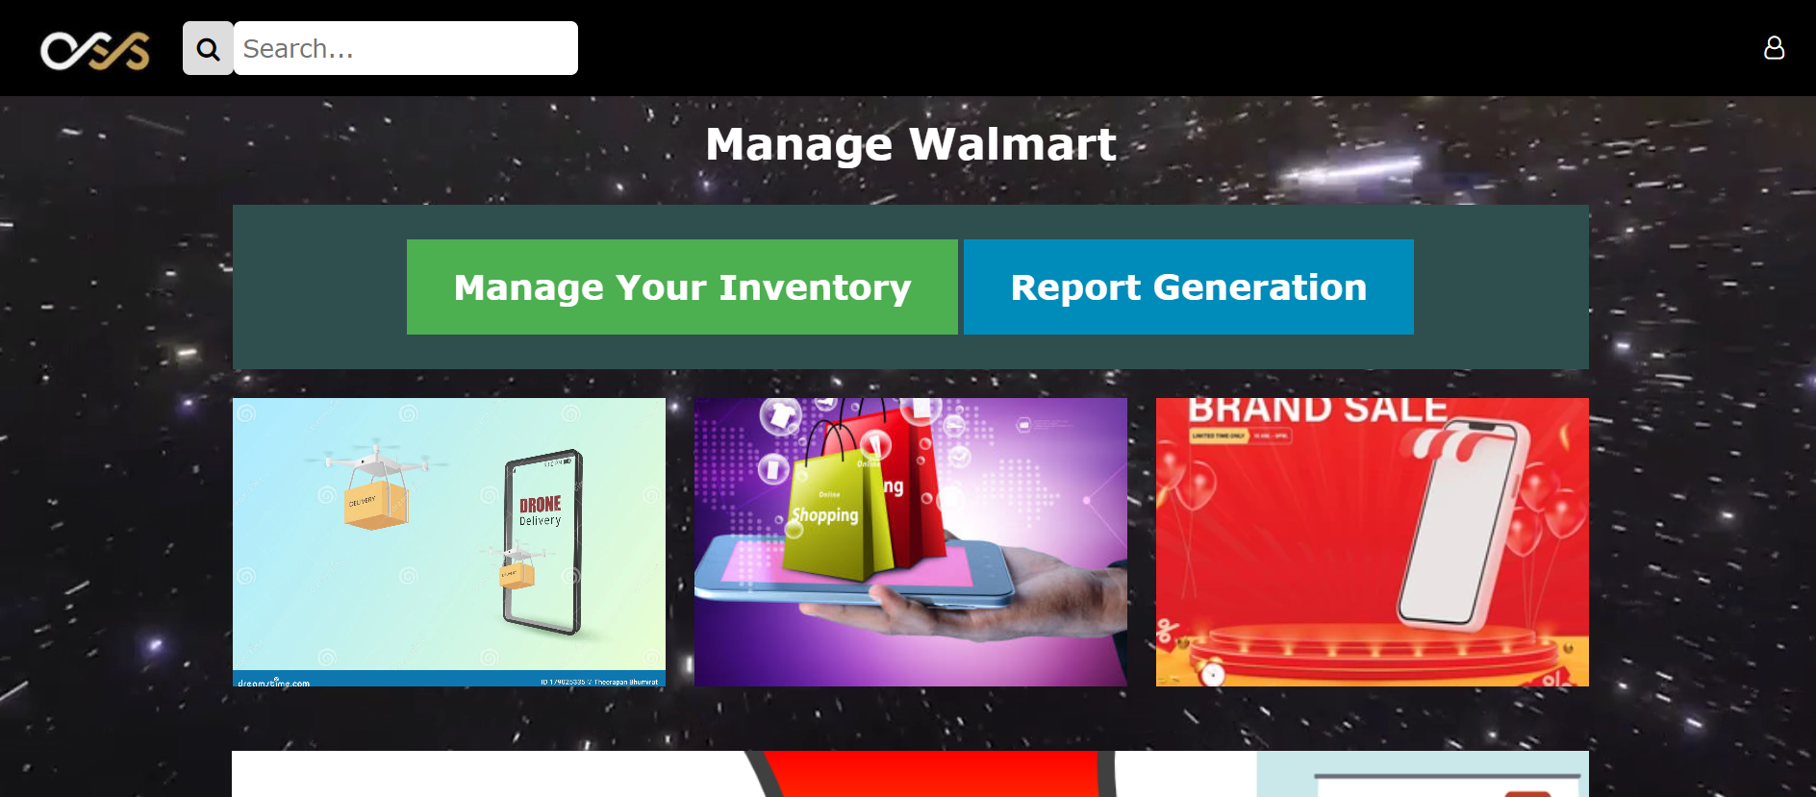

Click the report generation on the homepage.

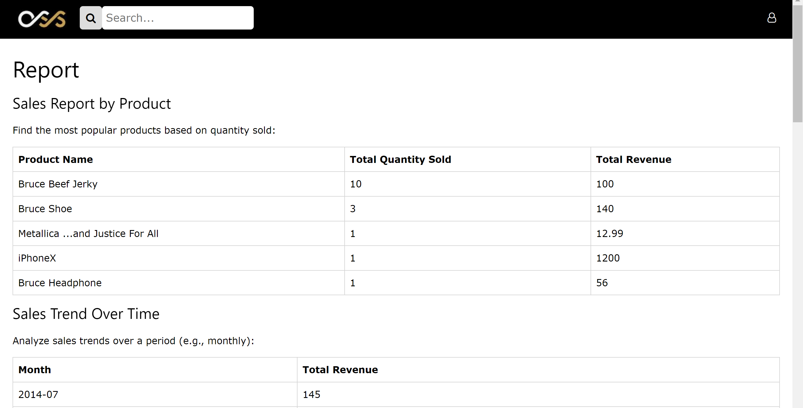

Then, it will provide the sales report regarding this store.

# Appendix

## Contact Information

Email: [123456789@connect.polyu.hk](mailto:123456789@connect.polyu.hk)

Phone Number: 12345678

If you encounter issues not addressed by this user guide, please contact your account manager for additional support. We wish you the greatest user experience with our Online Shopping System.